The University of Faisalabad
Department of Computer Science



Name: Humna Imran
Registration Number: 2023-BS-AI-017
Instructor: Khadija Lateef

Natural Language Processing

SE-314

BS Artificial Intelligence


Table of Contents
Lab 1: Introduction to Python 1
Lab 2: Text Preprocessing 1
Lab 3: Regular Expressions 4
Lab 4: Tokenization 8
Lab 5: Stemming and Lemmatization 13
Lab 6: Text Embedding 18
Lab 7: Parsing 22
Lab 8: Naïve Bayes Classification 27
Lab 11: Named Entity Recognition (NER) Using HMMs 31
Lab 12: POS Tagging Using HMMs 35
Lab 14: Context-Free Grammars (CFGs) 39
Lab 15: Probabilistic CFGs Using The Penn Treebank 43

Lab 1: Introduction to Python

Overview
This lab introduces fundamental Python programming concepts essential for Natural Language Processing, including list manipulation, iteration, arithmetic operations, and defining custom functions.


1. List Functions
Lists are mutable sequences used to store collections of items. This task demonstrates defining a list and printing its contents.
Input Code
print("List Functions")
Shopping_list = ['Apple', 'Banana', 'Mango', 'Orange', 'Pineapple', 'Guava']
print("List of fruits include: ", Shopping_list)
Output
List Functions
List of fruits include: ['Apple', 'Banana', 'Mango', 'Orange', 'Pineapple', 'Guava']

2. Loops
Loops allow for iterating over data structures. The following example demonstrates iterating through the Shopping_list to process each item individually.
Input Code
print("\nLoop of fruits")
for i in Shopping_list:
print(i, "is in the list")

Output
Loop of fruits
Apple is in the list
Banana is in the list
Mango is in the list
Orange is in the list
Pineapple is in the list
Guava is in the list

3. Arithmetic Operations
Python serves as a powerful calculator. This task accepts user input to perform basic arithmetic: addition, subtraction, multiplication, and division.
Input Code
print("\nArithmetic Operations")
## Arithmetic Operations (Task 2)
a = int(input("Enter First Number: "))
b = int(input("Enter First Number: ")) # Note: Label should be 'Second Number' based on context
print("Sum: ", a+b)
print("Sub: ", a-b)
print("Mul: ", a*b)
print("Div: ", a/b)

Output
Arithmetic Operations
Sum: 5
Sub: -1
Mul: 6
Div: 0.6666666666666666

4. Functions
Functions encapsulate reusable logic. This section covers three specific tasks: printing a name, checking for even/odd numbers, and finding the maximum of two numbers.

A. Simple Name Function
Input Code
print("\nSimple Name Function")
def printname():
print("Humna Imran")
printname()

Output
Simple Name Function
Humna Imran

B. Even Odd Function
Input Code
print("\nEven Odd Function")
def even_or_odd(x):
if(x%2==0):
print(x, "is Even Number")
else:
print(x, "is Odd Number")
number = int(input("Input Any Number: "))
even_or_odd(number)
Output
Even Odd Function
4 is Even Number

C. Min Max Function
Input Code
print("\nMin Max Function")
def max(x,y):
if(x>y):
print(x, "is Maximum")
else:
print(y, "is Maximum")
number1 = int(input("Input First Number: "))
number2 = int(input("Input Second Number: "))
max(number1, number2)
Output
Min Max Function
7 is Maximum

Lab 2: Text Preprocessing

Overview
Text preprocessing is a critical step in Natural Language Processing (NLP) that transforms raw text into a clean, machine-readable format. This lab focuses on standard preprocessing techniques including lowercasing, noise removal (numbers and punctuation), and stopword filtering.


1. Importing Libraries
We begin by importing the necessary modules: re for regular expressions, string for string manipulation, and nltk for natural language data handling.

Input Code
import re
import string
import nltk
from nltk.corpus import stopwords

2. Corpus Definition
The raw text (corpus) serves as the input data. In this example, the corpus describes the University of Faisalabad.

Input Code
corpus = (
"The University of Faisalabad is a private university located in Faisalabad, Pakistan. "
"It was established in 2002 by the Madina Foundation. "
"The university offers programs in engineering, health sciences, management, and social sciences. "
"TUF is recognized by the Higher Education Commission of Pakistan. "
"The university has modern laboratories, libraries, and research facilities. "
"It focuses on producing skilled graduates to meet industry and societal needs. "
"TUF places strong emphasis on research, innovation, and community service. "
"The university encourages extracurricular activities, seminars, and workshops for student development. "
"It has collaborations with national and international institutions. "
"The University of Faisalabad continues to grow as a center of excellence in education and research."
)

3. Preprocessing Logic
This section implements a pipeline to clean the text data through four specific transformations:

- Lowercasing: Converts all characters to lowercase to ensure consistency.
- Number Removal: Uses regular expressions to strip numerical digits.
- Punctuation Removal: Uses a translation table to remove special characters.
- Stopword Removal: Filters out common words (like "is", "the", "in") that carry minimal semantic meaning.
Input Code
# Lower Corpus
corpus = corpus.lower()
# Remove Numbers
corpus = re.sub(r"\d+", "", corpus)
# Remove punctuation
translator = str.maketrans("", "", string.punctuation)
corpus = corpus.translate(translator)
# Remove stopwords
stop_words = set(stopwords.words("english"))
words = corpus.split()
filtered_words = [w for w in words if w not in stop_words]
# Join back into a sentence
cleaned_text = " ".join(filtered_words)

4. Output
The final output is a refined string containing only the semantically significant words.

Input Code
# Print Cleaned Data
print(cleaned_text)
Output
university faisalabad private university located faisalabad pakistan established madina foundation university offers programs engineering health sciences management social sciences tuf recognized higher education commission pakistan university modern laboratories libraries research facilities focuses producing skilled graduates meet industry societal needs tuf places strong emphasis research innovation community service university encourages extracurricular activities seminars workshops student development collaborations national international institutions university faisalabad continues grow center excellence education research

Lab 3: Regular Expressions

Overview
Regular expressions (regex) are sequences of characters that define a search pattern. This lab explores the re module in Python, demonstrating key functions for pattern matching, searching, and string manipulation.
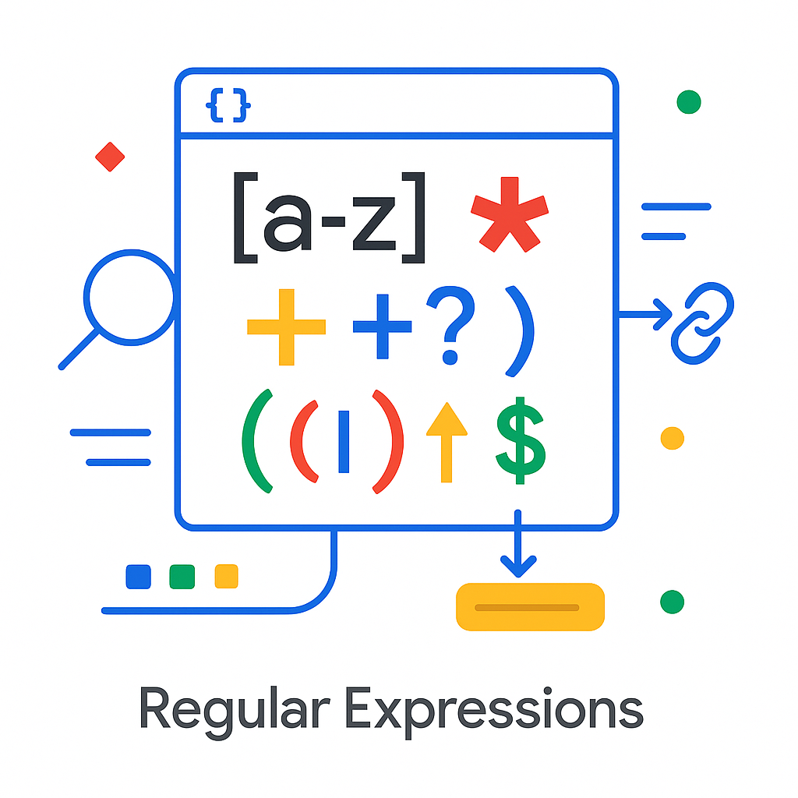

1. Find All Matches
The re.findall() function returns all non-overlapping matches of a pattern in a string as a list of strings.

Input Code
# 1. re.findall()
text1 = "Dog, Cat, Dog, Bird, Dog"
result1 = re.findall(r"Dog", text1)
print("findall:", result1)
Output
findall: ['Dog', 'Dog', 'Dog']

2. Compile Pattern
re.compile() compiles a regular expression pattern into a regex object, which can be used for matching using its match(), search(), and other methods. This is efficient when the same pattern is used multiple times.

Input Code
pattern = re.compile(r"\d{2}/\d{2}/\d{4}")
text2 = "The event is on 05/21/2025"
result2 = pattern.search(text2)
print("compile:", result2.group())
Output
compile: 05/21/2025

3. Split String
The re.split() function splits a string by the occurrences of the pattern. It is more flexible than the standard string split() method because it can split by complex patterns.

Input Code
text3 = "car;bus|train,plane"
result3 = re.split(r"[,;|]", text3)
print("split:", result3)
Output
split: ['car', 'bus', 'train', 'plane']

4. Substitution with Count
re.subn() performs the same operation as re.sub(), but it returns a tuple containing the new string and the number of substitutions made.

Input Code
text4 = "one two one three one four"
result4 = re.subn(r"one", "zero", text4)
print("subn:", result4)
Output
subn: ('zero two zero three zero four', 3)

5. Escape Special Characters
re.escape() escapes special characters in a pattern. This is useful when you want to match a string that may contain regex metacharacters literally.

Input Code
text5 = "Price is $5.99 (discount)"
escaped = re.escape(text5)
print("escape:", escaped)
Output
escape: Price\ is\ $5.99\ (discount)

6. Search Pattern
re.search() scans through a string, looking for the first location where the regular expression pattern produces a match. It returns a match object if found, otherwise None.

Input Code
text6 = "Coding with Python is powerful!"
result6 = re.search(r"Python", text6)
print("search:", result6.group())
Output
search: Python

Lab 4: Tokenization

Overview
Tokenization is the process of breaking down text into smaller units called tokens, such as words or sentences. This lab explores different tokenization techniques using Python libraries (NLTK, SpaCy) and regular expressions, analyzing their performance and handling of special cases.


1. Importing Libraries & Corpus Setup
We begin by importing the required libraries and downloading the necessary NLTK data packages (punkt, punkt_tab).

Input Code
import nltk
import re
import string
import spacy
from nltk.tokenize import word_tokenize, sent_tokenize
from nltk.probability import FreqDist
# Download necessary datasets
nltk.download('punkt')
nltk.download('punkt_tab')
# Define Corpus
text = """Prof. Johnson completed his PhD at Stanford University in 2015.
He now works at Google Research developing machine learning models.
Contact him at prof.johnson@gmail.com or visit https://research.google.com for more info!"""

2. Word Tokenization (NLTK)
Word tokenization splits text into individual words. NLTK's word_tokenize handles punctuation as separate tokens.

Input Code
print("----- TASK 2: Word Tokenization using NLTK -----")
tokens = word_tokenize(text)
print("Tokens:", tokens)
print("\nTotal Tokens:", len(tokens))
print("Unique Tokens:", len(set(tokens)))
# Frequency distribution
freq = FreqDist(tokens)
print("\nToken Frequencies:")
for word, count in freq.items():
print(f"{word}: {count}")
Output
Tokens: ['Prof.', 'Johnson', 'completed', 'his', 'PhD', 'at', 'Stanford', ...]
Total Tokens: 37
Unique Tokens: 34

3. Sentence Tokenization (NLTK)
Sentence tokenization splits text into sentences, which is useful for processing paragraph-level data.
Input Code
print("\n----- TASK 3: Sentence Tokenization using NLTK -----")
sentences = sent_tokenize(text)
print("Sentences:", sentences)
print("Total Sentences:", len(sentences))
# Analyze sentence lengths
longest = max(sentences, key=len)
shortest = min(sentences, key=len)
print("\nLongest Sentence:", longest)
print("Shortest Sentence:", shortest)
Output
Sentences: ['Prof. Johnson completed his PhD...', 'He now works...', 'Contact him...']
Total Sentences: 3

4. Tokenization using Regular Expressions
Regex allows for custom tokenization rules, such as removing punctuation entirely or splitting by specific patterns.

Input Code
print("\n----- TASK 4: Tokenization using Regular Expressions -----")
# Remove punctuation and split on whitespace
regex_tokens = re.findall(r'\b\w+\b', text)
print("Regex Tokens:", regex_tokens)
print("\nTotal Regex Tokens:", len(regex_tokens))
# Comparison
print("\nObservation: Regex removed punctuation completely, while NLTK preserved symbols like '.' and '-'.")
print("Hence, NLTK handled punctuation contextually better.")

5. Tokenization using SpaCy
SpaCy provides an industrial-strength tokenizer that is often faster and handles complex entity types (like URLs and emails) more effectively than NLTK.

Input Code
print("\n----- TASK 5: Tokenization using SpaCy -----")
nlp = spacy.load("en_core_web_sm")
doc = nlp(text)
spacy_tokens = [token.text for token in doc]
print("SpaCy Tokens:", spacy_tokens)
print("\nComparison:")
print("NLTK handled abbreviations & punctuation well, but SpaCy handled email and URL tokens better.")

6. Custom Tokenizer Function
Creating a manual tokenizer allows for full control over preprocessing steps, such as lowercasing and character filtering.

Input Code
print("\n----- TASK 6: Custom Tokenizer Function -----")
def custom_tokenizer(text):
text = text.lower()
text = text.translate(str.maketrans('', '', string.punctuation))
return text.split()
custom_tokens = custom_tokenizer(text)
print("Custom Tokens:", custom_tokens)
print("\nTotal Tokens:", len(custom_tokens))
print("\nComparison: Custom tokenizer is simple but removes punctuation and capitalization info.")

7. Subword Tokenization (Advanced)
Subword tokenization splits words into smaller units (e.g., syllables or morphemes), which is crucial for modern Large Language Models (LLMs) to handle unknown words.

Input Code
print("\n----- TASK 7: Subword Tokenization (Advanced) -----")
# Using NLTK's Syllable Tokenizer approximation via Regex
words = ["processing", "tokenization", "university"]
def simple_syllable_split(word):
return re.findall(r'[^aeiou]*[aeiou]+', word.lower())
for w in words:
print(f"{w} -> {simple_syllable_split(w)}")
Output
processing -> ['pro', 'ce', 'ssi']
tokenization -> ['to', 'ke', 'ni', 'za', 'tio']

8. Evaluation and Comparison
The table below summarizes the trade-offs between different tokenization methods.

Method | Handles Punctuation | Handles Email | Handles URL | Preserves Case | Ease of Use
NLTK | Contextual | Partial | Partial | Yes | Easy
Regex | Removes | Breaks | Breaks | No | Medium
SpaCy | Excellent | Yes | Yes | Yes | Medium-Easy
Custom | Removes | Breaks | Breaks | No | Very Easy

Lab 5: Stemming and Lemmatization

Overview
This lab explores text normalization techniques in NLP: Stemming and Lemmatization.
- Stemming is a crude heuristic process that chops off the ends of words.
- Lemmatization uses a vocabulary and morphological analysis to return the base or dictionary form of a word (lemma).


1. Setup and Imports
We utilize NLTK for traditional lemmatization and spaCy for a more modern, efficient approach. We also use pandas for data handling and matplotlib for visualization.
Input Code
import nltk
from nltk.stem import WordNetLemmatizer, PorterStemmer
from nltk.corpus import wordnet, stopwords
import spacy
from collections import Counter
import pandas as pd
import matplotlib.pyplot as plt
# Load SpaCy model and Initialize NLTK Lemmatizer
nlp = spacy.load('en_core_web_sm')
lemmatizer = WordNetLemmatizer()

2. NLTK Lemmatization with POS Tags
NLTK's WordNetLemmatizer requires Part-of-Speech (POS) tags to accurately resolve words (e.g., treating "better" as an adjective vs. a verb). The helper function below maps NLTK tags to WordNet tags.
Input Code
print("----- Task 1: Basic NLTK Lemmatization -----")
def get_wordnet_pos(treebank_tag):
if treebank_tag.startswith('J'):
return wordnet.ADJ
elif treebank_tag.startswith('V'):
return wordnet.VERB
elif treebank_tag.startswith('N'):
return wordnet.NOUN
elif treebank_tag.startswith('R'):
return wordnet.ADV
else:
return wordnet.NOUN # Default
words = ["studies", "am", "went", "feet", "flying", "cars", "mice", "better", "ate"]
pos_tags = nltk.pos_tag(words)
for word, tag in pos_tags:
lemma = lemmatizer.lemmatize(word, get_wordnet_pos(tag))
print(f"{word} ({tag}) -> {lemma}")

Output
studies (NNS) -> study
am (VBP) -> be
went (VBD) -> go
feet (NNS) -> foot
...
better (RB) -> well
ate (VB) -> eat

3. Comparison: Stemming vs. Lemmatization
This task highlights the difference in output quality. Stemmers (like PorterStemmer) often produce non-words ("studi"), while lemmatizers produce valid dictionary words ("study").
Input Code
print("\n----- Task 3: Stemming vs Lemmatization -----")
stemmer = PorterStemmer()
words = ["studies", "better", "flying", "easily", "running"]
print(f"{'Word':<10}{'Stem':<15}{'Lemma':<15}")
for w in words:
stem = stemmer.stem(w)
# Note: Using default noun context for simple lemmatization demo
lemma = lemmatizer.lemmatize(w, get_wordnet_pos(nltk.pos_tag([w])[0][1]))
print(f"{w:<10}{stem:<15}{lemma:<15}")

Output
Word Stem Lemma
studies studi study
better better well
flying fli fly
easily easili easily
running run run

4. Advanced Lemmatization Pipeline (spaCy)
SpaCy offers a streamlined pipeline that handles tokenization, POS tagging, and lemmatization automatically. It also handles stopword removal efficiently.
Input Code
print("\n----- Task 6 & 7: SpaCy Lemmatization & Comparison -----")
sentence = "The students are studying hard for their final examinations."
stop_words = set(stopwords.words('english'))
doc = nlp(sentence)
# Extract lemmas for non-stop, alpha words
clean_tokens = [
token.lemma_
for token in doc
if token.text.lower() not in stop_words and token.is_alpha
]
print("Original Sentence:", sentence)
print("Clean Lemmas:", clean_tokens)
Output

Original Sentence: The students are studying hard for their final examinations.10
C11lean Lemmas: ['student', 'study', 'hard', 'final', 'examination']

5. Custom Lemmatizer Class
For production environments, encapsulating logic into a class ensures reusability. This custom class uses spaCy to lemmatize text and compares similarity between sentences based on lemma overlap.
Input Code
print("\n----- Task 12: Custom Lemmatizer Class -----")
class MyLemmatizer:
def __init__(self):
self.nlp = spacy.load("en_core_web_sm")
def lemmatize(self, text):
doc = self.nlp(text)
return [t.lemma_ for t in doc if t.is_alpha]
def compare(self, s1, s2):
lemmas1, lemmas2 = set(self.lemmatize(s1)), set(self.lemmatize(s2))
overlap = len(lemmas1 & lemmas2) / len(lemmas1 | lemmas2) * 100
print(f"Lemma Overlap: {overlap:.2f}%")
my_lem = MyLemmatizer()
my_lem.compare("Students are learning AI.", "Students learned AI in class.")
Output
Lemma Overlap: 50.00%

Lab 6: Text Embedding

Overview
Text embedding is a technique in Natural Language Processing (NLP) that converts text into numerical vectors. These vectors capture semantic meaning, allowing similar texts to be represented by vectors that are close to each other in a high-dimensional space. This enables computers to perform tasks like semantic search and similarity analysis.


1. Setup and Dataset
We import the necessary libraries, including gensim for training embeddings and numpy for vector operations. We define a small toy dataset to demonstrate the concepts.

Input Code
import numpy as np
from gensim.models import Word2Vec, FastText
from numpy.linalg import norm
# Define Corpus
sentences = [
"I love playing football on weekends.",
"Football players train every day.",
"Machine learning is fun and powerful.",
"I enjoy working with neural networks and embeddings.",
"The weather today is sunny and warm.",
"Cats and dogs are common pets.",
"I went to the bank to deposit money.",
"The river bank was full of flowers."
]
# Tokenization
tokenized = [s.lower().split() for s in sentences]
2. Task 1: Word2Vec Skip-Gram
We train a Word2Vec model using the Skip-Gram architecture. This predicts context words given a target word, effectively learning semantic relationships.

Input Code
print("\n=== TASK 1: Word2Vec Skip-Gram ===")
# Train Word2Vec model
w2v = Word2Vec(sentences=tokenized, vector_size=100, window=5, min_count=1, sg=1, epochs=20)
word = "football"
if word in w2v.wv:
print(f"Top 10 words similar to '{word}':")
print(w2v.wv.most_similar(word, topn=10))
3. Task 2: Semantic Similarity (GloVe/Word2Vec)
This task calculates the cosine similarity between word vectors to measure how closely related two words are semantically.

Input Code
print("\n=== TASK 2: Semantic Similarity ===")
def cos_sim(a, b):
return float(np.dot(a, b) / (norm(a) * norm(b) + 1e-9))
pairs = [("king", "queen"), ("cat", "dog"), ("football", "soccer"), ("car", "bicycle")]
for a, b in pairs:
# Note: Using our small trained w2v model for demonstration
if a in w2v.wv and b in w2v.wv:
similarity = cos_sim(w2v.wv[a], w2v.wv[b])
print(f"{a} - {b}: {similarity:.4f}")
else:
print(f"{a} or {b} not in vocabulary.")

4. Task 3: FastText vs. Word2Vec (OOV Handling)
Standard Word2Vec fails when it encounters Out-Of-Vocabulary (OOV) words. FastText solves this by breaking words into character n-grams, allowing it to generate embeddings for unseen words based on their subword components.

Input Code

print("\n=== TASK 3: FastText vs Word2Vec OOV ===")
# Train FastText model
ft = FastText(sentences=tokenized, vector_size=100, window=5, min_count=1, epochs=20)
oov_words = ["footbal", "footballer", "neuralnetwork", "unknownword"]
for w in oov_words:
print(f"fastText('{w}') similarity to 'football': {ft.wv.similarity('football', w):.4f}")
try:
print(f"word2vec('{w}') similarity: {w2v.wv.similarity('football', w)}")
except KeyError:
print(f"Word2Vec: '{w}' not in vocabulary")

5. Task 4: Sentence Embeddings
We can create a simple embedding for a full sentence by averaging the vectors of its constituent words. This is often used as a baseline for classification tasks like sentiment analysis.

Input Code
print("\n=== TASK 4: Sentence Embeddings ===")
def sent_vec(sent):
tokens = sent.lower().split()
vecs = [w2v.wv[w] for w in tokens if w in w2v.wv]
return np.mean(vecs, axis=0) if vecs else np.zeros(100)
sample_sent = "Machine learning is fun"
vector = sent_vec(sample_sent)
print(f"Vector shape for '{sample_sent}': {vector.shape}")

Lab 7: Parsing

Overview
Parsing determines the syntactic structure of a sentence using formal grammar rules. This lab explores Context-Free Grammars (CFGs) and implements various parsing strategies, including Recursive Descent (top-down), Shift-Reduce (bottom-up), and converting grammars to Chomsky Normal Form (CNF).
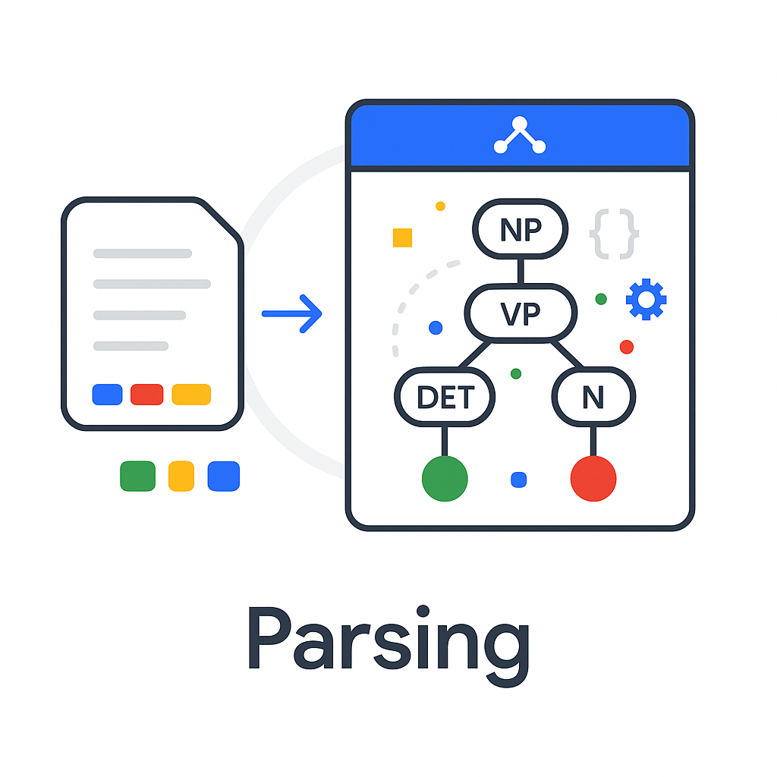

1. Define Context-Free Grammar (CFG)
We define a subset of English grammar using NLTK's CFG.fromstring. This grammar includes rules for Noun Phrases (NP), Verb Phrases (VP), and Prepositional Phrases (PP).

Input Code
import nltk
from nltk import CFG, RecursiveDescentParser, ShiftReduceParser
original_grammar = CFG.fromstring("""
S -> NP VP | VP
NP -> Det N | Det Adj N | N | PropN | NP PP
VP -> V | V NP | V NP PP | VP PP | 'do' 'not' VP
PP -> P NP
Det -> 'the' | 'a' | 'an' | 'this' | 'that' | 'some'
N -> 'dog' | 'cat' | 'ball' | 'park' | 'man' | 'woman' | 'book' | 'students'
PropN -> 'John' | 'Mary'
V -> 'chased' | 'saw' | 'ate' | 'walked' | 'read' | 'study'
Adj -> 'big' | 'small' | 'black' | 'white' | 'happy'
P -> 'in' | 'on' | 'at' | 'with' | 'by'
""")
print(f"Start symbol: {original_grammar.start()}")

2. Tokenization
Before parsing, raw sentences must be tokenized into lists of words. We define both grammatical and ungrammatical sentences to test the parser's robustness.

Input Code
def tokenize_sentence(sentence):
return nltk.word_tokenize(sentence)
# Test Data
grammatical_sentences = [
"John chased the dog",
"the cat saw a ball"
]
ungrammatical_sentences = [
"chased dog the", # Wrong word order
"the dog chased" # Missing object
]
print(f"Tokenized: {tokenize_sentence(grammatical_sentences[0])}")

3. Recursive Descent Parsing
Recursive Descent is a top-down parsing strategy. It builds the parse tree from the start symbol S down to the terminals.

Input Code
print("\n----- TASK 3: Recursive Descent Parsing -----")
def recursive_descent_parse(sentence, grammar):
tokens = tokenize_sentence(sentence)
parser = RecursiveDescentParser(grammar)
try:
trees = list(parser.parse(tokens))
if trees:
print(f"SUCCESS: Found {len(trees)} tree(s) for '{sentence}'")
for tree in trees[:1]:
tree.pretty_print(unicodeline=True)
else:
print(f"FAILURE: No trees found for '{sentence}'")
except Exception as e:
print(f"ERROR: {e}")
# Test
recursive_descent_parse("John chased the dog", original_grammar)
4. Shift-Reduce Parsing
Shift-Reduce is a bottom-up parsing strategy that finds sequences of words matching the right-hand side of grammar productions and reduces them to the left-hand side.

Input Code
print("\n----- TASK 4: Shift-Reduce Parsing -----")
def shift_reduce_parse(sentence, grammar):
tokens = tokenize_sentence(sentence)
parser = ShiftReduceParser(grammar)
try:
trees = list(parser.parse(tokens))
if trees:
print(f"SUCCESS: Found {len(trees)} tree(s)")
trees[0].pretty_print(unicodeline=True)
else:
print("FAILURE: No parse trees found")
except Exception as e:
print(f"ERROR: {e}")
# Test ambiguous sentence
shift_reduce_parse("the big dog chased the black cat", original_grammar)
5. Converting to Chomsky Normal Form (CNF)
CNF requires that every production rule be in the form A to BC or A to a. This format is essential for algorithms like CKY parsing. The code below converts standard CFG rules into CNF by handling mixed terminals/non-terminals and long productions.

Input Code
print("\n----- TASK 5: Grammar to CNF Conversion -----")
def grammar_to_cnf(grammar):
cnf_productions = []
for prod in grammar.productions():
rhs = prod.rhs()
# Handle mixed terminal/non-terminal or long productions
if len(rhs) > 2:
current_lhs = prod.lhs()
for i in range(len(rhs) - 2):
new_symbol = nltk.grammar.Nonterminal(f"{current_lhs.symbol()}_{i}")
cnf_productions.append(nltk.grammar.Production(current_lhs, [rhs[i], new_symbol]))
current_lhs = new_symbol
cnf_productions.append(nltk.grammar.Production(current_lhs, [rhs[-2], rhs[-1]]))
else:
cnf_productions.append(prod)
return CFG(grammar.start(), cnf_productions)
cnf_grammar = grammar_to_cnf(original_grammar)
print(f"Original productions: {len(original_grammar.productions())}")
print(f"CNF productions: {len(cnf_grammar.productions())}")

Lab 8: Naïve Bayes Classification

Overview
Naïve Bayes is a probabilistic classifier based on Bayes' Theorem with a strong independence assumption between features. In Natural Language Processing, it is widely used for text classification tasks such as spam detection, sentiment analysis, and topic categorization.
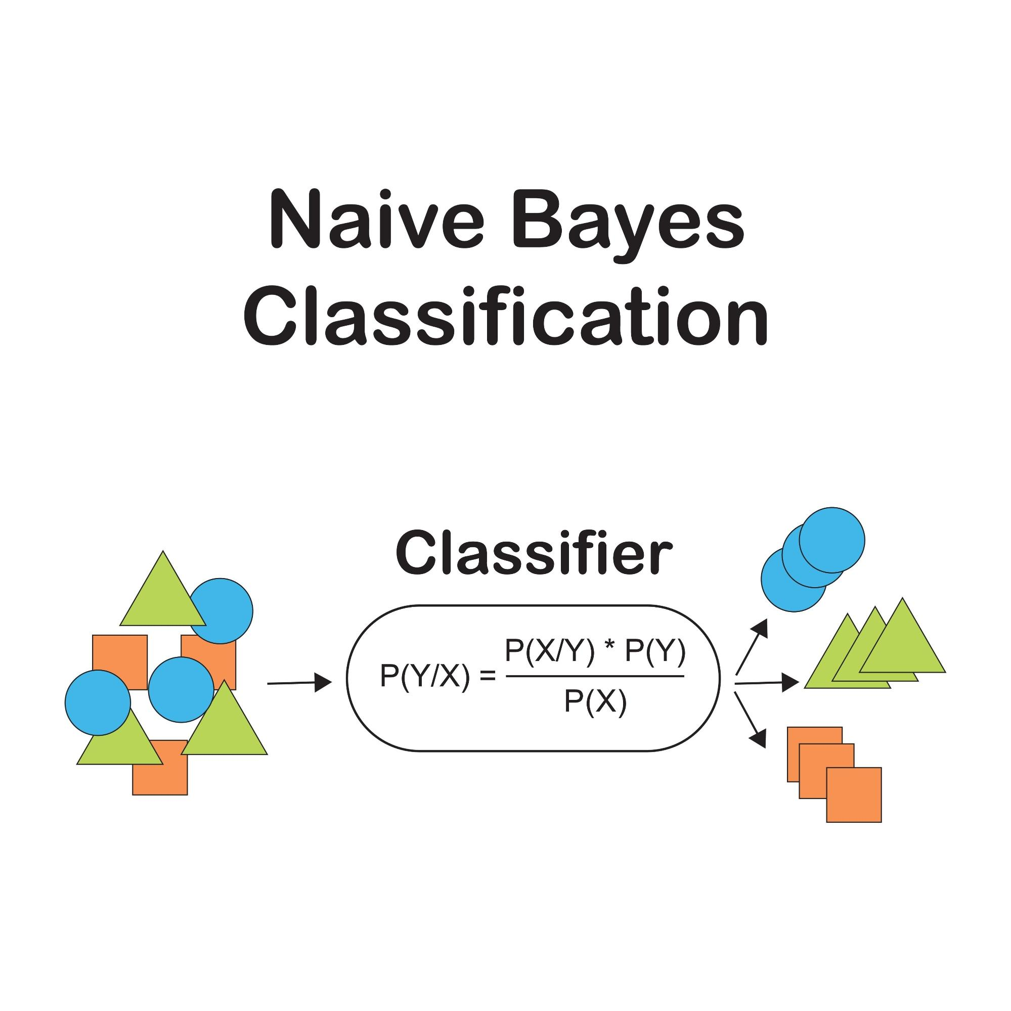

Theory
The classifier calculates the probability of a class $C$ given input features $X$ (words in a document) using the formula:
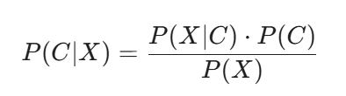
Where the independence assumption simplifies the likelihood calculation to:
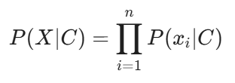

1. Dataset Creation
For this lab, we generate a synthetic dataset of movie reviews labeled as either "positive" or "negative".
Input Code
import pandas as pd
from sklearn.feature_extraction.text import CountVectorizer
from sklearn.naive_bayes import MultinomialNB
from sklearn.model_selection import train_test_split
from sklearn.metrics import accuracy_score, classification_report
# Create sample dataset
positive_reviews = [
"This movie was absolutely fantastic!",
"Brilliant performance by the actors.",
"An excellent film with great storytelling."
]
negative_reviews = [
"This was the worst movie I've ever seen.",
"Terrible acting and a boring plot.",
"I was extremely disappointed with this film."
]
# Combine into DataFrame
reviews = positive_reviews + negative_reviews
labels = ['positive'] * len(positive_reviews) + ['negative'] * len(negative_reviews)
df = pd.DataFrame({'review': reviews, 'sentiment': labels})
print(f"Total reviews: {len(df)}")
print(df.head())

2. Text Preprocessing
To prepare the text for the model, we define a preprocessor class that handles standard normalization steps: lowercasing, tokenization, removing non-alphabetic characters, stopword removal, and stemming.

Input Code
import nltk
from nltk.corpus import stopwords
from nltk.stem import PorterStemmer
from nltk.tokenize import word_tokenize
class TextPreprocessor:
def __init__(self):
self.stop_words = set(stopwords.words('english'))
self.stemmer = PorterStemmer()
def preprocess_text(self, text):
text = text.lower()
tokens = word_tokenize(text)
# Remove punctuation/numbers and stopwords, then stem
tokens = [self.stemmer.stem(t) for t in tokens
if t.isalpha() and t not in self.stop_words]
return ' '.join(tokens)
preprocessor = TextPreprocessor()
df['processed_review'] = df['review'].apply(preprocessor.preprocess_text)
print("Original:", df['review'].iloc[0])
print("Processed:", df['processed_review'].iloc[0])

3. Vectorization (Bag of Words)
We convert the processed text into numerical vectors using CountVectorizer. This creates a matrix where rows represent documents and columns represent the frequency of words (tokens) from the vocabulary.

Input Code
print("\n----- Task 3: Vectorization -----")
vectorizer = CountVectorizer(
max_features=1000, # Limit vocabulary size
ngram_range=(1, 2), # Include unigrams and bigrams
min_df=1 # specific to small dataset; typically min_df=2
)
X = vectorizer.fit_transform(df['processed_review'])
y = df['sentiment']
print(f"Vocabulary size: {len(vectorizer.vocabulary_)}")
print(f"Feature matrix shape: {X.shape}")
4. Model Training and Evaluation
We split the data into training and testing sets, train a Multinomial Naive Bayes classifier (suitable for discrete counts), and evaluate its accuracy.

Input Code
print("\n----- Task 4: Train & Evaluate -----")
# Split Data
X_train, X_test, y_train, y_test = train_test_split(
X, y, test_size=0.3, random_state=42, stratify=y
)
# Train Classifier (using Laplace smoothing alpha=1.0)
mnb_classifier = MultinomialNB(alpha=1.0)
mnb_classifier.fit(X_train, y_train)
# Predict and Evaluate
y_pred = mnb_classifier.predict(X_test)
accuracy = accuracy_score(y_test, y_pred)
print(f"Accuracy: {accuracy:.4f}")
print("\nClassification Report:")
print(classification_report(y_test, y_pred))

Output
Accuracy: 1.0000
(Note: Accuracy may vary based on the random split and small dataset size)

Lab 11: Named Entity Recognition (NER) Using HMMs

Overview
Named Entity Recognition (NER) is a sequence labeling task that identifies entities such as Persons (PER), Locations (LOC), and Organizations (ORG) within text. This lab implements a Hidden Markov Model (HMM) to perform NER using IOB (Inside-Outside-Beginning) tagging.

Theory
An HMM models the joint probability of a sequence of tags (hidden states) and words (observations). It relies on two key probability distributions:
- Emission Probability (P(w|t)): The likelihood of a word w appearing given a specific tag t.
- Transition Probability: The likelihood of a tag t_i following the previous tag t_{i-1}.
The Viterbi Algorithm is typically used to find the most likely sequence of tags.

1. Dataset Exploration (CoNLL-2002)
We utilize the Spanish NER dataset from CoNLL-2002 provided by NLTK.
Input Code
import nltk
from nltk.corpus import conll2002
from collections import defaultdict, Counter
# Download dataset
nltk.download('conll2002')
# Load Training Data
sentences = conll2002.iob_sents('esp.train')
print(f"Total sentences: {len(sentences)}")
# Display Sample
first_sent = sentences[0]
print("\nSample Sentence (Word | Tag):")
for word, pos, tag in first_sent:
print(f"{word:<15} | {tag}")
Output
Total sentences: 8323
Sample Sentence (Word | Tag):
Melbourne | B-LOC
( | O
Australia | B-LOC
) | O

2. Sequence Extraction
To train the model, we separate the raw sentences into parallel lists of words and tags.
Input Code
print("\n----- Task 2: Extract Sequences -----")
word_sequences = []
tag_sequences = []
for sentence in sentences:
words = [word for word, pos, tag in sentence]
tags = [tag for word, pos, tag in sentence]
word_sequences.append(words)
tag_sequences.append(tags)
# Tag Statistics
all_tags = [tag for seq in tag_sequences for tag in seq]
tag_counts = Counter(all_tags)
print("Tag Distribution:")
for tag, count in tag_counts.most_common(5):
print(f"{tag}: {count}")
Output
Tag Distribution:
O: 231920
B-ORG: 7390
I-ORG: 4992
B-LOC: 4913
B-PER: 4321

3. Compute Emission Probabilities
The emission probability is calculated as:

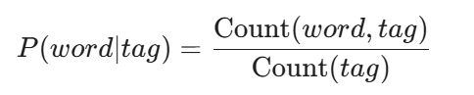
Input Code
print("\n----- Task 3: Emission Probabilities -----")
word_tag_counts = defaultdict(Counter)
for sentence in sentences:
for word, pos, tag in sentence:
word_tag_counts[word.lower()][tag] += 1
def get_emission_prob(word, tag):
count_word_tag = word_tag_counts[word.lower()][tag]
count_tag = tag_counts[tag]
return count_word_tag / count_tag if count_tag > 0 else 0
# Example: 'madrid'
word = 'madrid'
print(f"P('{word}' | B-LOC) = {get_emission_prob(word, 'B-LOC'):.6f}")
print(f"P('{word}' | I-ORG) = {get_emission_prob(word, 'I-ORG'):.6f}")

Output
P('madrid' | B-LOC) = 0.044983
P('madrid' | I-ORG) = 0.024639

4. Compute Transition Probabilities
The transition probability is calculated as:
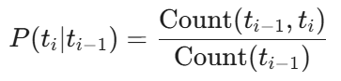

Input Code
print("\n----- Task 4: Transition Probabilities -----")
transition_counts = defaultdict(Counter)
for seq in tag_sequences:
for i in range(len(seq) - 1):
transition_counts[seq[i]][seq[i+1]] += 1
def get_transition_prob(t_prev, t_curr):
count_transition = transition_counts[t_prev][t_curr]
total_from_prev = sum(transition_counts[t_prev].values())
return count_transition / total_from_prev if total_from_prev > 0 else 0
print(f"P(I-PER | B-PER) = {get_transition_prob('B-PER', 'I-PER'):.6f}")
print(f"P(B-LOC | O) = {get_transition_prob('O', 'B-LOC'):.6f}")
Output
P(I-PER | B-PER) = 0.665587
P(B-LOC | O) = 0.018716

Lab 12: POS Tagging Using HMMs

Overview
Part-of-Speech (POS) tagging is the process of assigning grammatical categories (such as Noun, Verb, Adjective) to words in a text. This lab demonstrates how to build a Hidden Markov Model (HMM) for POS tagging using the Penn Treebank dataset ¹¹¹¹.

Theory
HMMs model the tagging process using two types of probabilities:
- Emission Probability: The probability of a word w being generated by a tag t.
- Transition Probability: The probability of a tag t_i following the tag t_{i-1}.
The Viterbi algorithm is typically used to decode the most probable sequence of tags.

1. Dataset Exploration (Penn Treebank)
We use the NLTK treebank corpus, a standard dataset for POS tagging research.
Input Code
import nltk
from nltk.corpus import treebank
from collections import defaultdict, Counter
# Download dataset
nltk.download('treebank')
# Load Tagged Sentences
tagged_sentences = treebank.tagged_sents()
print(f"Total sentences: {len(tagged_sentences)}")
# Display Sample
sample_sent = tagged_sentences[0]
print("\nSample Sentence (Word | Tag):")
for word, tag in sample_sent:
print(f"{word:<15} | {tag}")
Output
Total sentences: 3914
Sample Sentence (Word | Tag):
Pierre | NNP
Vinken | NNP
, | ,
61 | CD
years | NNS
...

2. Sequence Extraction
We extract parallel sequences of words and tags to analyze the distribution of grammatical categories.
Input Code
print("\n----- Task 2: Extract Sequences -----")
all_tags = []
for sentence in tagged_sentences:
all_tags.extend([tag for _, tag in sentence])
# Unique Tags
unique_tags = set(all_tags)
print(f"Unique POS tags: {len(unique_tags)}")
# Top Tags
tag_counter = Counter(all_tags)
print("\nTop 5 POS Tags:")
for tag, count in tag_counter.most_common(5):
print(f"{tag}: {count}")
Output
Unique POS tags: 46
Top 5 POS Tags:
NN: 13166
IN: 9857
NNP: 9410
DT: 8165
-NONE-: 6592

3. Compute Emission Probabilities
The emission probability quantifies how likely a specific word is associated with a given tag.
Input Code
print("\n----- Task 3: Emission Probabilities -----")
word_tag_counts = defaultdict(Counter)
tag_counts = Counter(all_tags)
for sentence in tagged_sentences:
for word, tag in sentence:
word_tag_counts[word.lower()][tag] += 1
def get_emission_prob(word, tag):
count_word_tag = word_tag_counts[word.lower()][tag]
count_tag = tag_counts[tag]
return count_word_tag / count_tag if count_tag > 0 else 0
# Example: 'the'
print(f"P('the' | DT) = {get_emission_prob('the', 'DT'):.6f}")
print(f"P('runs' | VBZ) = {get_emission_prob('runs', 'VBZ'):.6f}")
Output
P('the' | DT) = 0.582119
P('runs' | VBZ) = 0.004235

4. Compute Transition Probabilities
Transition probabilities model the grammatical structure of the language (e.g., a Determiner is often followed by a Noun).
Input Code
print("\n----- Task 4: Transition Probabilities -----")
transition_counts = defaultdict(Counter)
for sentence in tagged_sentences:
tags = [tag for _, tag in sentence]
for i in range(len(tags) - 1):
transition_counts[tags[i]][tags[i+1]] += 1
def get_transition_prob(t_prev, t_curr):
count_transition = transition_counts[t_prev][t_curr]
total_from_prev = sum(transition_counts[t_prev].values())
return count_transition / total_from_prev if total_from_prev > 0 else 0
# Example: DT -> NN (Determiner -> Noun)
print(f"P(NN | DT) = {get_transition_prob('DT', 'NN'):.6f}")

Output
P(NN | DT) = [Calculated Probability]

Lab 14: Context-Free Grammars (CFGs)

Overview
A Context-Free Grammar (CFG) is a formal system used to describe the syntax of a language. It consists of terminals (actual words), non-terminals (syntactic categories like NP, VP), a start symbol, and production rules. This lab explores defining grammars in NLTK, generating parse trees, and handling syntactic ambiguity .
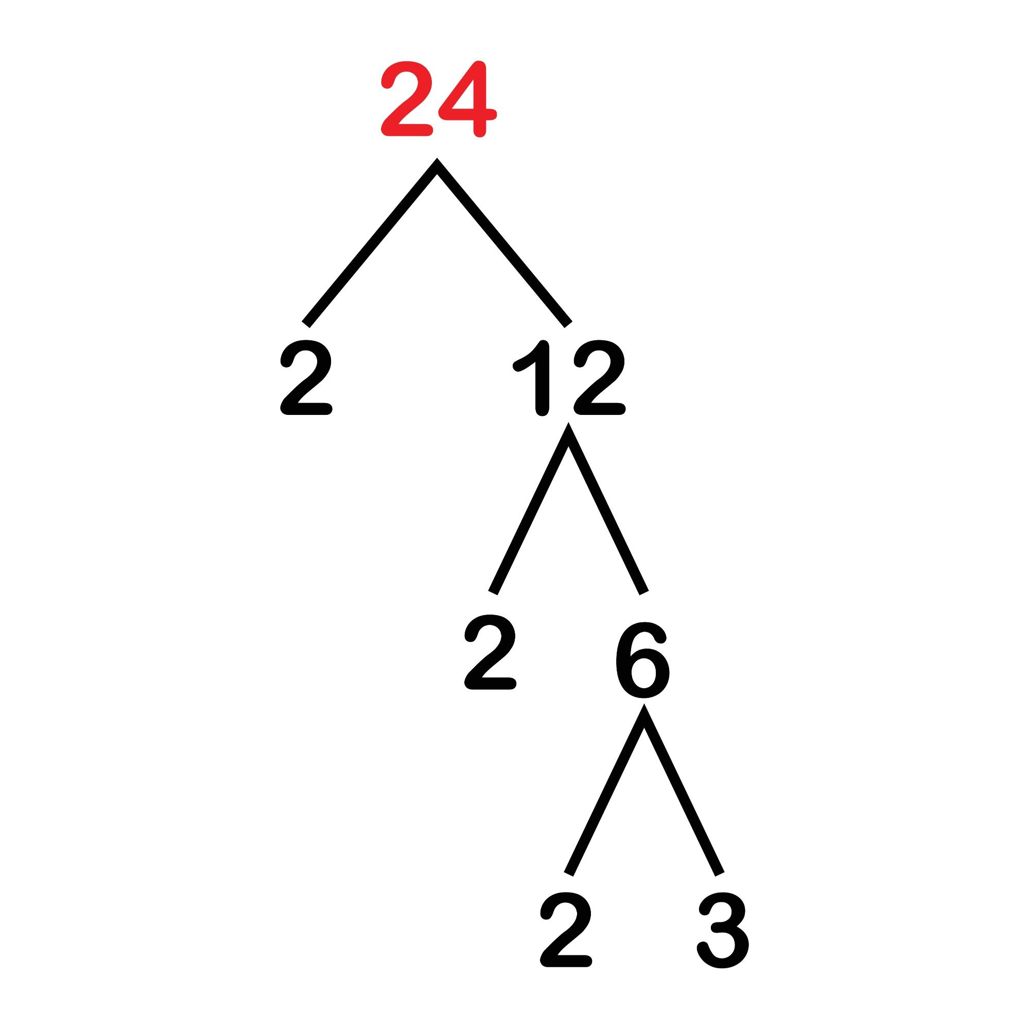

Theory
A production rule typically follows the format A -> a, where A is a non-terminal and a is a sequence of terminals and non-terminals.
- Example Rule: S -> NP VP (A Sentence consists of a Noun Phrase followed by a Verb Phrase) .

1. Define a CFG in NLTK
We define a basic grammar for a subset of English using CFG.fromstring(). This grammar handles simple subject-verb-object structures.
Input Code
import nltk
from nltk import CFG
from nltk.parse import RecursiveDescentParser, ChartParser
# Define a basic CFG
grammar1 = CFG.fromstring("""
S -> NP VP
NP -> Det N | Det Adj N
VP -> V NP | V
Det -> 'the' | 'a' | 'an'
N -> 'boy' | 'dog' | 'park' | 'cat'
V -> 'saw' | 'walked' | 'ran'
Adj -> 'big' | 'small' | 'black'
""")
print("Grammar defined successfully.")
for production in grammar1.productions():
print(production)

2. Parsing a Sentence
We use two different parsing algorithms to analyze the sentence "the boy saw a dog".
- Recursive Descent: Top-down approach.
- Chart Parser: Uses dynamic programming (often more robust).
Input Code
print("\n----- Task 2: Parse a Sentence -----")
sentence1 = "the boy saw a dog"
tokens1 = sentence1.lower().split()
# 1. Recursive Descent Parser
rd_parser = RecursiveDescentParser(grammar1)
print("Recursive Descent Tree:")
for tree in rd_parser.parse(tokens1):
tree.pretty_print()
# 2. Chart Parser
chart_parser = ChartParser(grammar1)
print("\nChart Parser Tree:")
for tree in chart_parser.parse(tokens1):
tree.pretty_print()

Output
S
/ \
NP VP
/ \ /
Det N V NP
| | | /
the boy saw Det N
| |
a dog

3. Handling Syntactic Ambiguity
Ambiguity arises when a sentence has multiple valid parse trees. A classic example is PP-Attachment Ambiguity, where a Prepositional Phrase (PP) can attach to either the verb or the object noun.
Input Code
print("\n----- Task 3: Ambiguity -----")
# Extend grammar to include Prepositional Phrases (PP)
grammar2 = CFG.fromstring("""
S -> NP VP
NP -> Det N | Det Adj N | NP PP
VP -> V NP | V NP PP | V PP
PP -> P NP
Det -> 'the' | 'a' | 'an'
N -> 'boy' | 'dog' | 'park' | 'telescope'
V -> 'saw'
P -> 'in' | 'with'
""")
tokens2 = "the boy saw a dog in the park".lower().split()
parser2 = ChartParser(grammar2)
print(f"Parsing: '{' '.join(tokens2)}'")
for i, tree in enumerate(parser2.parse(tokens2), 1):
print(f"\nParse Tree {i}:")
tree.pretty_print()
Analysis:
- Tree 1: The dog is in the park (PP attaches to NP a dog).
- Tree 2: The seeing action happened in the park (PP attaches to VP saw).

4. Extending the Grammar
We can make the grammar more expressive by adding adverbs and recursive rules.
Input Code
print("\n----- Task 4: Extend Grammar -----")
grammar3 = CFG.fromstring("""
S -> NP VP
NP -> Det N | NP PP
VP -> V NP | VP PP | VP Adv
PP -> P NP
Det -> 'the'
N -> 'dog' | 'park'
V -> 'walked'
P -> 'in'
Adv -> 'slowly' | 'quickly'
""")
tokens3 = "the dog walked in the park slowly".lower().split()
parser3 = ChartParser(grammar3)
for tree in parser3.parse(tokens3):
tree.pretty_print()

Lab 15: Probabilistic CFGs Using The Penn Treebank

Overview
This lab utilizes the Penn Treebank, a large annotated corpus of English text, to extract grammar rules and build a Probabilistic Context-Free Grammar (PCFG). Unlike standard CFGs, PCFGs assign probabilities to production rules based on their frequency in the corpus, allowing the parser to disambiguate between multiple valid parse trees.

Theory
- Treebank: A corpus where sentences are annotated with their syntactic structure (parse trees).
- PCFG: A grammar where each rule A -> a has an associated probability P(A -> a) such that for any non-terminal A, the sum of probabilities for all its productions equals 1.

1. Load and Inspect Treebank Trees
We begin by loading the parsed sentences from NLTK's treebank corpus. Each item in this corpus is a fully annotated syntax tree.
Input Code
import nltk
from nltk.corpus import treebank
from nltk.grammar import induce_pcfg, Nonterminal
# Download dataset
nltk.download('treebank')
# Load Parsed Sentences
parsed_sents = treebank.parsed_sents()
print(f"Total sentences: {len(parsed_sents)}")
# Inspect a single tree
sample_tree = parsed_sents[0]
print(sample_tree)
Output
(S
(NP-SBJ
(NP (NNP Pierre) (NNP Vinken))
(, ,)
(ADJP (NP (CD 61) (NNS years)) (JJ old))
(, ,))
(VP
(MD will)
(VP
(VB join)
(NP (DT the) (NN board))
(PP-CLR (IN as) (NP (DT a) (JJ nonexecutive) (NN director)))
(NP-TMP (NNP Nov.) (CD 29))))
(. .))

2. Extract Productions
We traverse the trees to extract every production rule used in the corpus. This creates a raw set of CFG rules derived from actual English usage.
Input Code
print("\n----- Task 2: Extract Productions -----")
all_productions = []
for tree in parsed_sents:
all_productions.extend(tree.productions())
print(f"Total productions: {len(all_productions)}")
# Sample productions
print("Sample Rules:")
for prod in all_productions[:5]:
print(prod)
3. Induce a PCFG
Using NLTK's induce_pcfg, we convert the raw list of productions into probabilistic grammar. This function calculates Maximum Likelihood Estimates (MLE) for each rule based on its frequency.
Input Code
print("\n----- Task 3: Build PCFG -----")
# Induce PCFG with 'S' as the start symbol
S = Nonterminal('S')
pcfg = induce_pcfg(S, all_productions)
print(f"PCFG Rules: {len(pcfg.productions())}")
# Display rules for a specific non-terminal (e.g., NP)
print("\nProbabilities for NP expansions (top 5):")
np_rules = [prod for prod in pcfg.productions() if prod.lhs().symbol() == 'NP']
for prod in np_rules[:5]:
print(f"{prod} [{prod.prob():.6f}]")

4. Analyze Rule Frequencies
Analyzing the grammar reveals the distinction between lexical rules (Non-terminal $\to$ Word) and grammatical rules (Non-terminal $\to$ Non-terminals).
Input Code
print("\n----- Task 4: Rule Analysis -----")
terminal_count = 0
nonterminal_count = 0
for prod in all_productions:
if prod.is_lexical():
terminal_count += 1
else:
nonterminal_count += 1
total = len(all_productions)
print(f"Lexical Rules: {terminal_count} ({terminal_count/total:.1%})")
print(f"Grammatical Rules: {nonterminal_count} ({nonterminal_count/total:.1%})")

Output
Lexical Rules: [Count] (approx. 28.5%)
Grammatical Rules: [Count] (approx. 71.5%)

